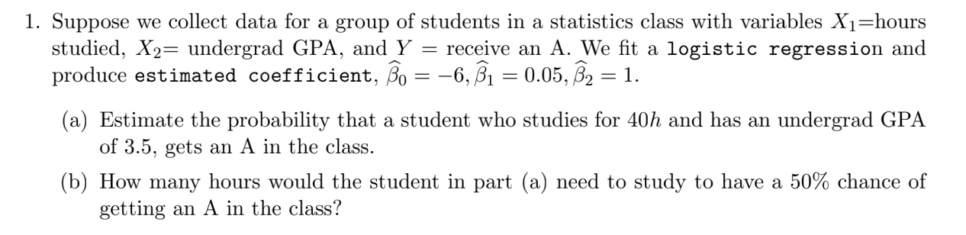

a)

Paras: 40h and GPA is 3.5. We can get:

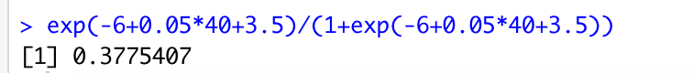

b)

50% percent to get A, 10 hours are required.

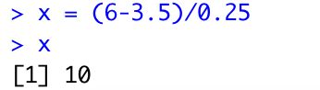

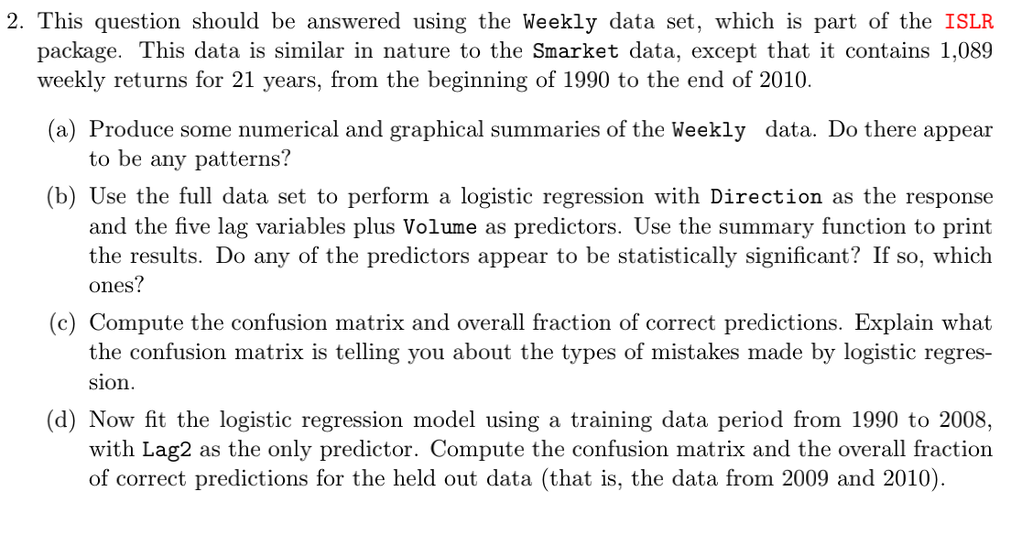

a)

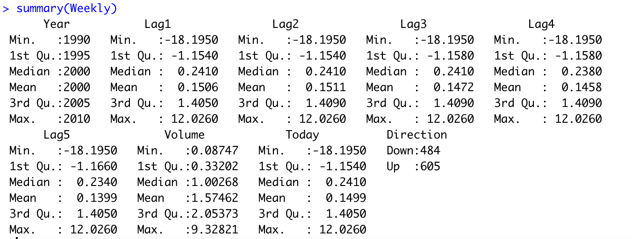

Numerical summary:

year from 1990 to 2010. discrete variable

Lag1, Lag2, Lag3, Lag4, Lag5 are almost normal distribution. continuous variable.

Volume, Today are continuous variable.

Direction, only up and down discrete variable

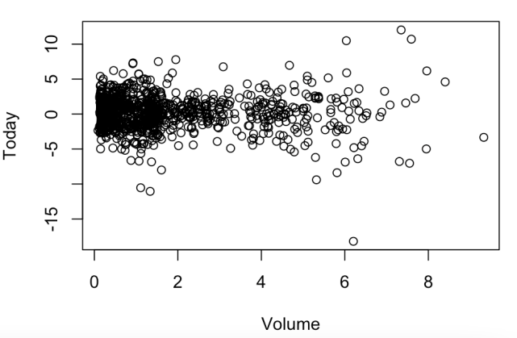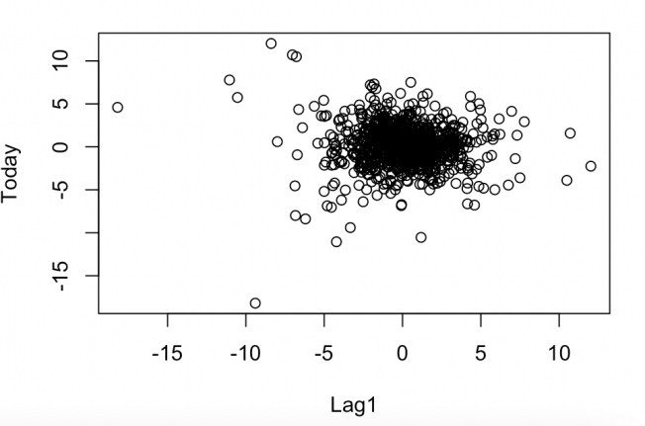

b)

Yeah, the significant predictors only include Lag2.

Because only Lag2’s p value is smaller than 0.05. Except for Intercept, because this is not predictor.

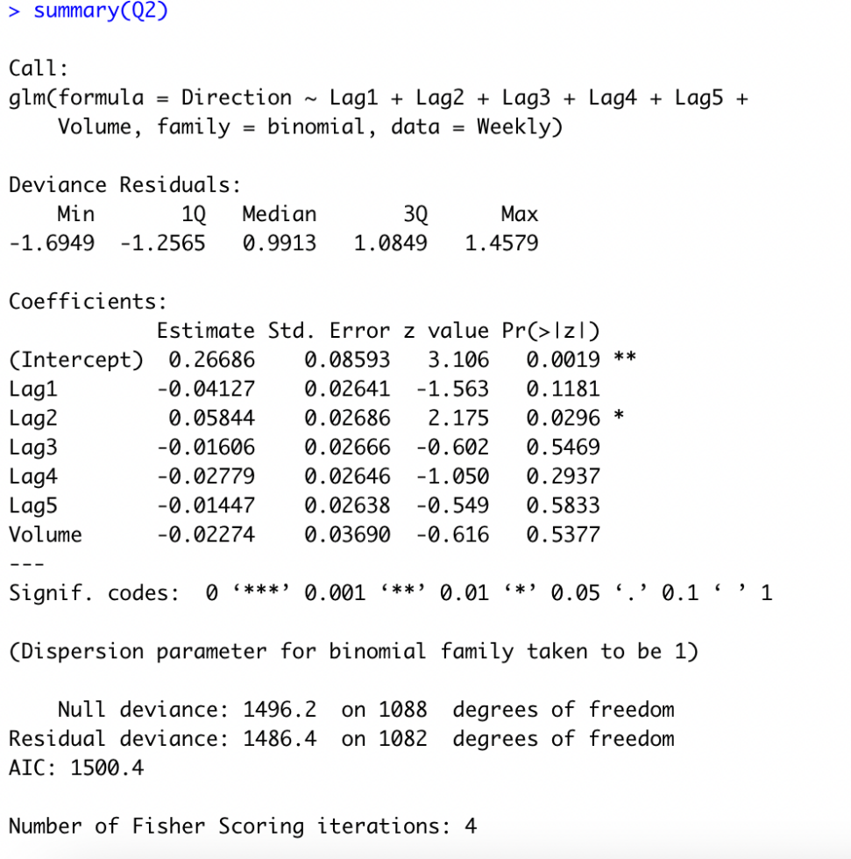

C)

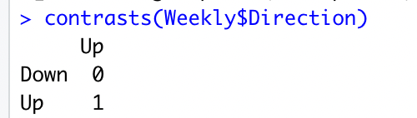

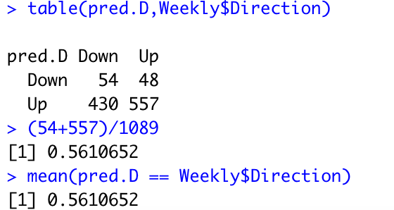

Explain:

Remember: Down is 0 which means it is original assumption.

Pred.D Down but actual is Up, is Type Two Error.

Pred.D Up but actual is Down , is Type One Error.

overall fraction of correct predictions:  
 (54+557)/1089 = 0.5610652

d)

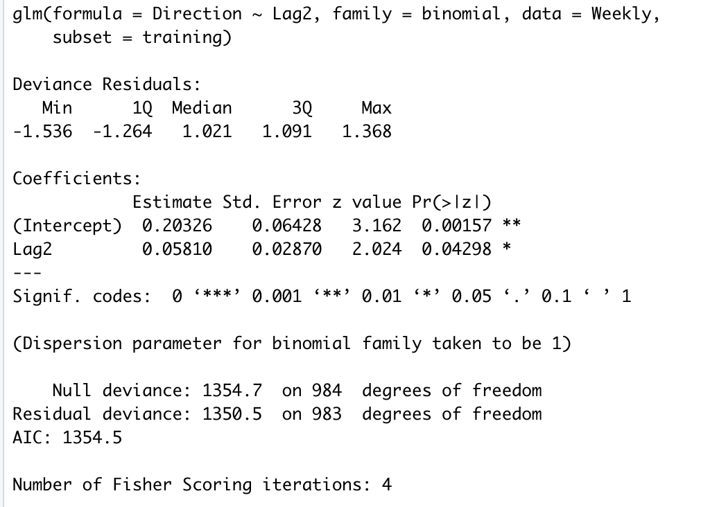

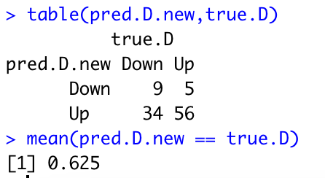

overall fraction of correct predictions:  
 0.625